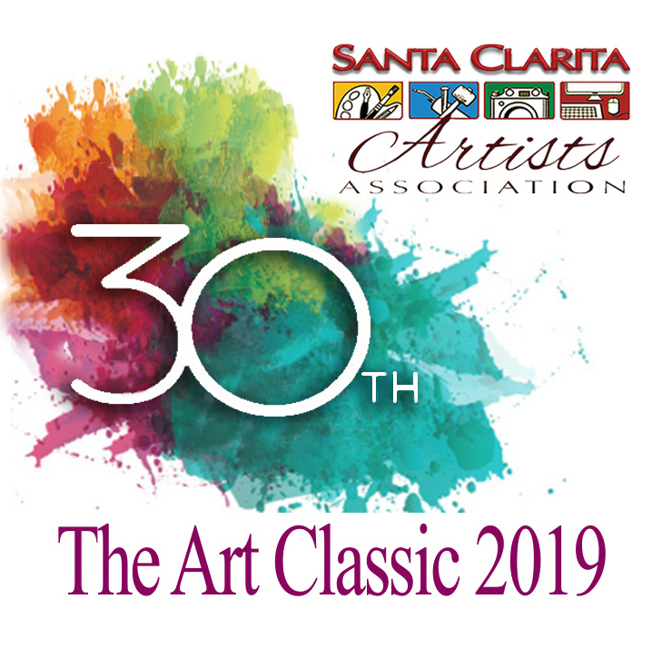
Call to Artists
Santa Clarita Artists Association
2019 Art Classic Fine Arts Competition &
30th Anniversary Celebration
Celebrate with us:
Friday, November 1, 10:00 am – 8:30 pm
Hyatt Hotel, 24500 Town Center Drive, Valencia, CA 91355

- The SCAA Art Classic 30th Anniversary Celebration is bigger than ever before both in events planned and hours we are open. It is being held at the Hyatt Hotel Grand Ballroom and will be open from 10:00 am – 8:30 pm on Friday, November 1.
- In addition to the professionally judged competition, there will be demo artists, small works for sale, and members’ art on display and for sale in the foyer.
- This year cash prizes will be awarded as follows: Best of Show $300, First Place in all media $50, Second place in all media $25. Additionally, ribbons and palette pins will be awarded to all winners including Merit Award winners.
- A Live Auction will be held at our Gala reception between 5:00 - 8:30 as well as our Silent Auction which will be happening all day.
- All participating artists will have entry to the Art Classic Gala. Additional tickets for the Gala may be purchased for $25 each online and at the door. All participants are asked to promote the event and to sell 2 tickets.
- Besides being a day to celebrate the work of SCAA fine artists, the Art Classic is a fundraiser that supports our local high school scholarship program. The Silent Auction is a big part of our fundraiser. Please complete the attached silent auction form to make your donation. Gift baskets, collectables, and community donations sell well! Small artworks will be for sale separately.

Entry Requirements:
You can enter and pay on our website or by mail through the following link:
http://www.santaclaritaartists.org/art-classic-entry-form.html
1. SCAA members only. Membership applications are available at: http://www.santaclaritaartists.org
2. Artwork may not have been entered in a previous Art Classic.
3. Artwork must be the original creation of the artist and not derived from another person’s photo or artwork.
4. Artwork should have been created in the past three years.
5. No artwork prepared in a classroom or workshop may be entered.
6. Artists may enter 2 artworks not to exceed 27”x27” or 1 artwork larger than 27”x27” but no larger than 48”x48”. All dimensions are including frame. There is no size limit on sculptures. Artists may enter one sculpture and one small hanging piece (27”x27” or less) of art or 2 sculptures.
7. Fees are: $35 for 1 artwork 27”x27” or smaller, $45 for 2 artworks, each 27”x27” or smaller or $45 for 1 artwork larger than 27”x27” up to 48”x48”. 8. 2D work must be wired and ready to hang. Absolutely no saw tooth hangers. Canvas edges must be painted if no frame is used. NO WET PAINTINGS!

9. All artwork must be for sale.
10. After entering, you will receive a packet containing tickets, labels, postcards a 30th Anniversary button (please wear to promote), and further instructions.

Categories: Categories are: Acrylic, Dry Media, Masters (all media), Mixed Media/Other, Oil, Photography, Sculpture/3D Media, and Watercolor. Any category with fewer than 6 submissions will be judged with Mixed Media/Other. The category entered by the artist on the Entry Form is subject to change. If in question, the Art Classic Committee will determine the correct category for each piece. Changes made by the Committee are final.

Awards: Best of Show $300, Gold $50 each category, Silver $25 each category, and Merit. Ribbons and palette pins will be awarded to each winner. There is also an “Excellence
In Art” Award given by the City of Santa Clarita.

To move into the “Masters” category, an accumulated score of 8 points must be obtained from the Art Classic Fine Arts Competition starting in 2009. Master points are awarded as follows: Best of Show 4 points, Gold 3 points, Silver 2 points. No points are given for other awards.

Dates to Remember:
- Deadline for Entry: midnight, October 1, 2019
- Delivery of Artwork to the Hyatt Hotel: Thursday, October 31st, 11:00 am – 2:00 pm.
- Delivery of all Silent Auction items to the Hyatt Hotel: Thursday, October 31st, 11:00 am – 2:00 pm.
- Open to the Public, Friday, November 1, 10:00 am – 5:00 pm.
- Gala 30th Anniversary Celebration: Friday, November 1, 5:00 pm – 8:30 pm
- Pick up Art: At the conclusion of the Gala, Friday, November 1, approximately 8:30 pm

All winning artwork will be hung at the Hyatt Hotel. If a winning piece is sold at the Art Classic, the artist may submit another piece of art for approval by the Hyatt management.

Questions: Please contact Art Classic co-chair Jeanne Iler, (661) 678-0357 or Zony Gordon, (661) 312-3422. The Entry Form, Waiver Form, and Silent Auction Form follow this page. The waiver statement must be signed to complete your application. Please read it thoroughly.

